BC Hardware & Software
cm_hw_sw.php — Basic Concepts
Define ICT
Hardware and Software
Data vs Information

Hardware & Software

To touch or not to touch….
Hardware is all the parts of the computer that you can touch.
Think about the IPO cycle. You can classify hardware according to the job it does in this cycle, namely Input, Processing, Output, Storage and Communication.
Software is all the untouchable instructions that tell the CPU what to do - the code that makes the computer able to get stuff done.
Software can be divided into three main categories, namely System software, Application Software and Embedded software.
Software needs hardware to run on. Hardware is just a big, expensive paperweight without software to control it.
Both these concepts are important enough to have their own dedicated chapters.
You need to work through both the lessons below (originally encountered in the
Define ICT
module) to make sure you have a good grasp of hardware, software and examples of both.

Hardware
Input
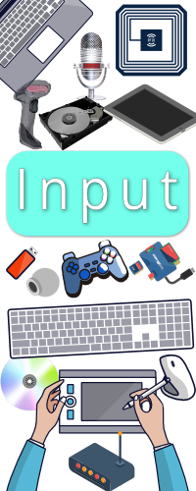
Input is how the computer gets data and instructions.
Anything that provides the computer with data or instructions qualifies as input hardware. This includes:
- Keyboard
- Mouse
- Microphone
- Webcam
- Digitising tablet
- Touchscreen
- Trackpad
- Any form of storage
- RGID / NFC
- Scanner
- Any form of sensor
- Any form of data communications device
The keyboard, mouse and touchscreen are the most commonly used input devices.
Output
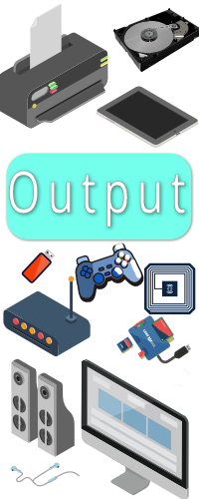
Output is how the computer shows what it is doing.
Anything that makes a sound, vibrates, displays something, creates something physical or accepts and stores / communicates data qualifies as output hardware.
- Screen
- Printer
- Speaker
- Headphones
- 3D Printer
- Touchscreen
- Any form of storage
- Any device that vibrates
- RFID / NFC
- Virtual Reality headset
- Any form of data communications device
The screen, speaker / headphones, printer and touchscreen are the most commonly used output devices.
Storage
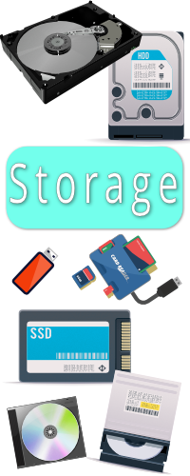
Storage is where the computer keeps data and instruction for the long term.
When the computer wants to use something from storage it first has to load it into memory.
Examples of storage include:
- Magnetic storage - Hard drives
- Optical storage - CD, DVD, Blu Ray
- Electronic storage - Flash drive, SSD
Storage is an essential component of any computing system. Without it the computer could not 'remember' work that was done previously and even software would first have to be types in before it could be run!
Optical storage (followed by magnetic storage) is the slowest storage. Magnetic storage is the cheapest form of storage.
SSDs are the fastest and most expensive form of storage - but using an SSD instead of a hard drive is the most effective way to speed up your computer.
Storage capacity is measured in Gigabytes or Terabytes.
Processing
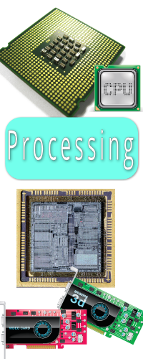
The Central Processing Unit or CPU is where all the work is done.
Data and instructions are loaded into memory from any form of input (including storage).
The CPU fetches the instructions and data it needs to work on, does its work and then sends the results back to memory.
CPUs work at speeds measured in billions of instructions per second (Ghz or Gigahertz).
If your computer has a dedicated video card then it has another type of processor - the GPU or Graphics Processing Unit.
The GPU is normally dedicated to rendering 3D graphics for display, but it is actually a processor that is very good at maths.
This means that sometimes the CPU can be programmed to share its work with the GPU for programs that do a lot of intense mathematical calculations.
Manufacturers of CPUs are:
- Intel (Desktop)
- AMD (Desktop & GPU)
- nVidia (GPU)
- Qualcomm (Mobile)
- Apple (Mobile)
- Samsung Exynos (Mobile)
- Broadcom (Mobile)
Memory
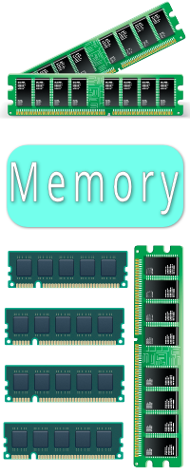
Memory is where the computer keeps the data and instructions it needs to work with.
There are two basic types of Memory, namely RAM (Random Access Memory) and ROM (Read Only Memory).
Memory is electronic, much faster than any form of storage and therefore much more expensive than storage. Computers therefore have much less memory than they have storage.
The most important thing to understand about memory is this:
Memory is also volatile - that means it changes easily and will lose its contents when the computer is switched off or loses power due to a power failure.
All the work that you do on a computer is kept in Memory. The only way to keep it permanently is to save it to storage.
If you quit a program without saving your work then that work is removed from memory along with the program instructions and is lost (unless you saved it first).
Data Communications
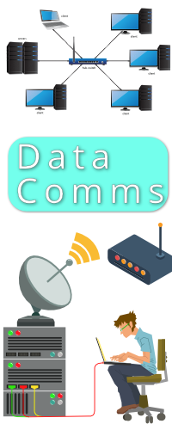
Data Comms is shorthand for all the different types of technologies used to allow computers to communicate with each other.
This includes networking technologies and technologies that allow computers to communicate with each other remotely.
The first type of device to allow computers to communicate over a telephone was called a modem (a combination of the words modulator - demodulator).
The job of the modem was to convert the digital signals of the computer into sound (modulate) so it could travel down the telephone line. Then it had to convert the sound back into digital signals (demodulate) for the computer to work with the data.
Most modern communications such as cellphone radio, ADSL and Fibre are completely digital and don't need a modem - in the sense of the old fashioned device. The thing is, people are lazy and easily confused. These technologies do need a box that is best called a DTE (Data Terminating Equipment) to manage the sending and receiving of data on the line.
To prevent confusion, companies have simply kept on calling these boxes 'modems' because that is what people understand to make data communications possible.
A router is hardware that makes it possible for your local network to connect to the internet. In most cases the router is combined with the modem into a single device.
Data Comms is a technical topic, filled with lots of jargon (as you can see from the section above) and will be explained in detail in the Data Comms module.
Software
Operating Systems
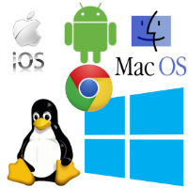
The Operating System (abbreviated OS) is the software which runs the computer. It performs all the functions listed under System Software.
The general area of Operating Systems is now divided into TWO main categories, namely:
Desktop & Laptop Operating Systems
This includes Windows, macOS and Linux.
Mobile Operating Systems
This includes iOS and Android.
Back to the top of this Panel
Application Software
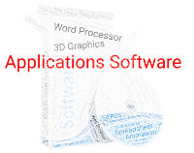
Applications software includes all the different types of software you use to get specific jobs done.
Examples include:
- Word Processing
- Spreadsheets
- Presentation Software
- Databases
- Graphics software (bitmaps, vector, 3D)
- Financial / Accounting software
- CAD
- and much more.
This is discussed in much more detail in the Software chapter.
Back to the top of this Panel
Software Distribution
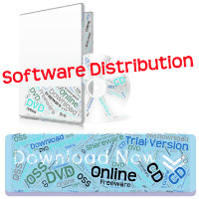
Software distribution is all about how you get the software you install on your device.
Examples include:
Proprietary Software
You buy a license to use the software and can continue to use it as long as you have a computer that can run it.
Shareware / Trial version
Software that you can 'try before you buy' - the software works for a limited time / has limited features until you pay for it.
Freeware
Software that is free to use but you don't have access to the source code.
Open Source Software
Software where you have access to the source code. You can still pay for the software, but most of the time it is free.
Subscription Software (SaaS)
This is software that you rent. It works as long as you keep paying a monthly / yearly fee. This is also known as Software as a Service (SaaS).
Adware
Software that is 'free' but displays adverts that make money for the creator of the software.
Back to the top of this Panel

Quizzes

Practice Quiz
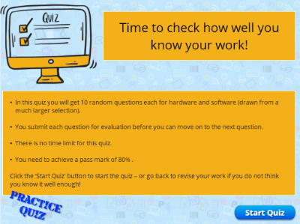
This quiz lets you do random questions with no time limit. It will be slightly different each time you take it.

Practice Quiz - ALL QUESTIONS
This quiz lets you do all the questions in the Hardware and Software quiz.
You do not have to complete the quiz all at once, but can come back and continue where you left off.

FINAL QUIZ!
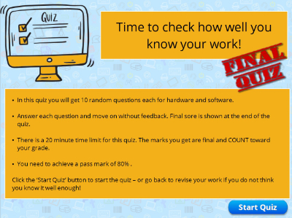
This quiz lets you do random questions - with a time limit.
NB: This quiz can only be taken once and your marks are final.

Prev:

Define ICT
Back to Top

Next: Data and Information

Video Links - Keyboards & Pointing Devices
We have selected and curated a set of videos on YouTube related to your course.
These videos are not created or owned by us.
They may display advertising and in some cases may contain limited amounts of swearing.
Loading...
{ "service": "youtube", "method" : "playlist_videos", "options": { "max_count": 50, "max_cache_age": 15 }, "parameters" : { "playlist" :"PL2HRXufnVD1yHM_MUdaiCS2yQvC-vqorN", "channel" :"UCnNk0Zm9qZvPIGahKsyqH8A", "query" :"RapidWeaver" } }

Video Links - Screens and Projectors
We have selected and curated a set of videos on YouTube related to your course.
These videos are not created or owned by us.
They may display advertising and in some cases may contain limited amounts of swearing.
Loading...
{ "service": "youtube", "method" : "playlist_videos", "options": { "max_count": 50, "max_cache_age": 15 }, "parameters" : { "playlist" :"PL2HRXufnVD1z2iLzsauPkMLebNcnJ9Oo5", "channel" :"UCnNk0Zm9qZvPIGahKsyqH8A", "query" :"RapidWeaver" } }

Video Links - Printing
We have selected and curated a set of videos on YouTube related to your course.
These videos are not created or owned by us.
They may display advertising and in some cases may contain limited amounts of swearing.
Loading...
{ "service": "youtube", "method" : "playlist_videos", "options": { "max_count": 50, "max_cache_age": 15 }, "parameters" : { "playlist" :"PL2HRXufnVD1wxa14JTzB3f2OPa8am7sgs", "channel" :"UCnNk0Zm9qZvPIGahKsyqH8A", "query" :"RapidWeaver" } }

Video Links - System Software
We have selected and curated a set of videos on YouTube related to your course.
These videos are not created or owned by us.
They may display advertising and in some cases may contain limited amounts of swearing.
Loading...
{ "service": "youtube", "method" : "playlist_videos", "options": { "max_count": 50, "max_cache_age": 15 }, "parameters" : { "playlist" :"PL2HRXufnVD1x3Pb3zJT2NTGViSCtDYLEq", "channel" :"UCnNk0Zm9qZvPIGahKsyqH8A", "query" :"RapidWeaver" } }

Video Links - Software Distribution
We have selected and curated a set of videos on YouTube related to your course.
These videos are not created or owned by us.
They may display advertising and in some cases may contain limited amounts of swearing.
Loading...
{ "service": "youtube", "method" : "playlist_videos", "options": { "max_count": 50, "max_cache_age": 15 }, "parameters" : { "playlist" :"PL2HRXufnVD1xLziFL-B2OMgujyYeCQy2l", "channel" :"UCnNk0Zm9qZvPIGahKsyqH8A", "query" :"RapidWeaver" } }

Notes for this Module
What to look out for and do in this module...
The FAQs are not questions that are likely to appear in exam papers - they are real questions that most people ask about the content.

FAQs for this module
Questions on Hardware and Software - and their answers...

Network Types FAQ
View the questions or type in the term you are looking for below…
No results were found

Do all computers have an OS?
The answer is a qualified 'Yes'.
Some dedicated, embedded devices don't have or need an OS.
All other computers have an OS.

Is it possible to have a hardware only or software only computer?
No.
Software needs hardware to run on.
Hardware needs software to tell it what to do.

Is all hardware limited to one category?
No.
Some devices are multi-purpose.
Most multi-purpose devices can be used for both input and output.

Where does software come from?
It is written by people.

Can computers get input without human involvement?
Yes.
This is done using sensors, storage or data communication.

Can computers give output without involving humans?
This is done by controlling machinery, writing to storage or transmitting data communications.

Is all OSS Free?
Yes - if you get the source code you can compile the software to work on your computer.
That said, it is possible to buy OSS - pre-compiled, with an installer, help system, manual and support. These extra features are what you are paying for.

What happens if I stop paying my subscription for SaaS?
The software stops working.

